CSA0908 JAVA PROGRAMMING
SLOT - B
Section A: Multiple-Choice Questions (10 Questions)
1. Mixed Types and Integer Division
int a = 7, b = 2;
double r = a / b + a % b * 0.5;
System.out.println(r);
A) 3.0
B) 4.0
C) 3.5
D) 4.5
Explanation:
- a / b gives 7 / 2 = 3 because both are integers. The decimal part is discarded.
- a % b gives 7 % 2 = 1 (the remainder).
- 1 * 0.5 = 0.5.
- Add the results: 3 + 0.5 = 3.5.
The correct output is actually 3.5 (Option C).

2. Identify the Error
byte x = 10;
byte y = 20;
byte z = x + y;
System.out.println(z);
A) 30
B) Compilation error
C) -26
D) Runtime exception
Correct answer: B) Compilation error

Explanation:
In Java, arithmetic involving byte, short, and char values generally promotes them to int.
- x + y becomes an int expression.
- Java does not automatically assign that int result to a byte variable.
- Therefore, byte z = x + y; causes a compilation error.
Correction:

byte z = (byte) (x + y);
System.out.println(z);

3. Unary Operators and Precedence
int a = 4, b = 6;
int c = a++ * 2 + --b;
System.out.println(a + " " + b + " " + c);
A) 5 6 14
B) 4 5 13
C) 5 5 14
D) 5 5 13
Correct answer: C) 5 5 14
Explanation:
- a++ uses the original value 4, then increments a to 5.
- 4 * 2 = 8.
- --b decrements b from 6 to 5, then uses 5.
- c = 8 + 5 = 13.

4. Which if Does the else Belong To?
int x = 5;
if (x > 3)
if (x > 10)
System.out.println("A")
else
System.out.println("B");
A) B
B) A
C) Both A and B are printed
D) Nothing is printed
correct answer: A) B
Explanation:
- x > 3 is true.
- x > 10 is false.
- The else belongs to the nearest unmatched if, which is if (x > 10).
- So "B" is printed.

5. Switch and Missing break
int day = 2;
switch (day) {
case 1: System.out.print("Mon ");
case 2: System.out.print("Tue ");
case 3: System.out.print("Wed "); break;
case 4: System.out.print("Thu ");
default: System.out.print("Off");
}
A) Tue
B) Mon Tue Wed
C) Tue Wed
D) Tue Wed Thu Off
Correct answer: C) Tue Wed

Explanation:
- day = 2, so execution starts at case 2.
- It prints Tue.
- There is no break after case 2, so execution continues to case 3.
- It prints Wed and stops at break.

6. Switch Rules
double grade = 2.0;
switch (grade) {
case 2.0: System.out.println("Two"); break;
default: System.out.println("Other");
}
A) Compilation error
B) Two
C) Other
D) Nothing is printed
Correct answer: A) Compilation error
Explanation:
In a traditional Java switch statement, a double variable cannot be used as the switch expression. Java supports types such as int, char, String, and enum, but not double.
Therefore, the program will not compile.

7. Short-Circuit Evaluation
int a = 5, b = 10;
boolean r = (a > 5) && (++b > 10) || (b++ > 9);
System.out.println(a + " " + b + " " + r);
A) 5 10 false
B) 5 11 false
C) 5 12 true
D) 5 11 true
Correct answer: D) 5 11 true
Explanation:
- a > 5 means 5 > 5, which is false.
- Because the left side of && is false, ++b is not executed. So b remains 10.
- The expression before || is false, so Java evaluates (b++ > 9).
- b++ uses 10 for the comparison. Since 10 > 9 is true, r becomes true.
- After the comparison, b increases to 11.

8. char Arithmetic and Type Promotion
char c = 'A';
c += 2;
System.out.println(c + 1);
A) D
B) 68
C) 67
D) Compilation error
Correct answer: B) 68
Explanation:
- The character 'A' has the numeric value 65.
- c += 2 changes c to the character with value 67, which is 'C'.
- In c + 1, the character is promoted to an integer.
- 67 + 1 = 68.

9. Ternary Operator with Side Effects
int a = 8, b = 12;
int m = (a > b) ? a++ : b--;
System.out.println(a + " " + b + " " + m);
A) 8 11 12
B) 9 12 8
C) 8 11 11
D) 9 11 12
Correct answer: A) 8 11 12
Explanation:
- a > b means 8 > 12, which is false.
- Therefore, Java executes only b--.
- Post-decrement returns the original value 12 to m, then reduces b to 11.
- a remains 8.

10. Input and Output Methods
The user types 12 5 (separated by a space) when the program runs.
Scanner sc = new Scanner(System.in);
int a = sc.nextInt();
int b = sc.nextInt();
System.out.print(a + b);
System.out.println(a - b);
A) 17 7
B) 24
C) 17 and 7 on two separate lines
D) 177
Correct answer: A) 177
Explanation:
- a = 12 and b = 5.
- a + b = 17. print() displays 17 without a newline.
- a - b = 7. println() displays 7 and then moves to the next line.

Section B: Scenario-Based Programming Questions (3 Questions)

Problem 1: Candy Sharing
Scenario: A teacher wants to share candies equally among the students in her class. Any candies that
cannot be shared equally will be kept by her.
Problem Statement: Write a program that reads the total number of candies and the number of students.
Display how many candies each student gets and how many candies are left over.
Input Format: Two integers on one line: the number of candies, then the number of students.
Output Format: Two lines:
Each student gets: <number>
Candies left: <number>
Constraints:
• 0 ≤ candies ≤ 10000
• 1 ≤ students ≤ 100

PROGRAM:
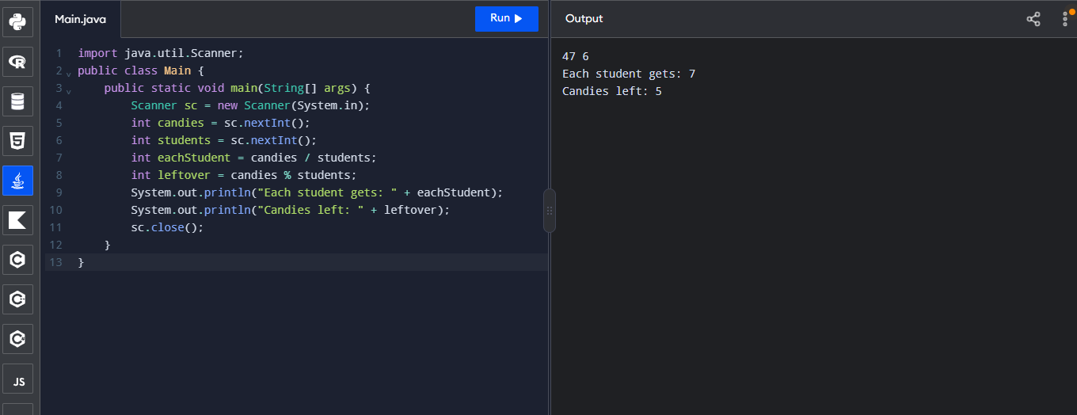

Problem 2: Amusement Park Ride Eligibility
Scenario: An amusement park has a roller coaster with safety rules. A rider is allowed on the ride if
either of these is true:
• The rider is at least 10 years old and at least 120 cm tall; or
• The rider is at least 100 cm tall and is accompanied by an adult.
Problem Statement: Write a program that reads the rider's age, height, and whether an adult
accompanies them, and decides if the rider is allowed.
Input Format: Three integers on one line: age (in years), height (in cm), and adult accompanying (1 for
yes, 0 for no).
Output Format: Print ALLOWED or NOT ALLOWED.
Constraints:
• 1 ≤ age ≤ 90
• 50 ≤ height ≤ 220
• The third value is either 0 or 1
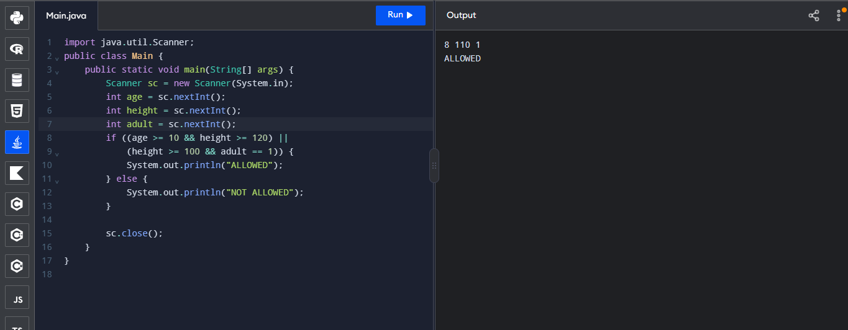

Problem 3: College Canteen Billing
Scenario: The college canteen uses a numbered menu:
Code Item Price (Rs.)
1 Veg Burger 60
2 Sandwich 50
3 Pasta 120
4 Cold Coffee 80
A customer orders one type of item in some quantity. If the bill is Rs. 500 or more, a 10% discount is
given on the bill.
Problem Statement: Write a program that reads the item code and quantity and prints the final amount
payable. If the item code is not between 1 and 4, print an error message instead.
Input Format: Two integers on one line: item code, then quantity.
Output Format:
• For a valid code: Amount payable: <amount> (the amount as a decimal number, for example
540.0)
• For an invalid code: Invalid choice
Constraints: 1 ≤ quantity ≤ 50
